http://www.bbc.co.uk/schools/parents/resources/
www.mathszone.co.uk
http://www.woodlands-junior.kent.sch.uk/maths/
http://www.coolmath4kids.com/
http://www.comberps.newtownards.ni.sch.uk/maths_games_for_ks1.htm
http://www.year2maths.co.uk/numberfacts/num1/make10/make10.htm
www.ngfl-cymru.org.uk
www.numicon.com
www.mangahigh.com
www.parentsintouch.co.uk

Maths is all around us and we’re using it
every day!

Many of you will already be doing these
mathematical activities and practising your
child’s numerical skills without even thinking
about it!
The most important thing is to make learning
maths FUN!

Booklet 3


Whatever you do, make sure your children ENJOY their Mathematics!
If they struggle to understand, make mistakes or get bored; keep calm, make it easier, change the subject, tell them a joke, play football, go to the park but please don’t get cross or impatient – you could put them off maths for life!

Addition
Pupils are encouraged to use empty number lines and count on from the largest number, irrespective of the order of calculation.
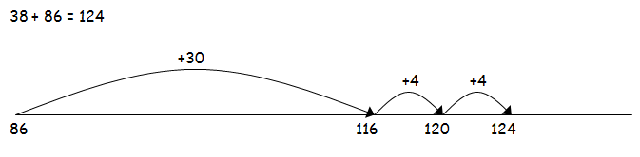
Pupils are encouraged to look for near multiples of ten when adding and then adjusting as required e.g.
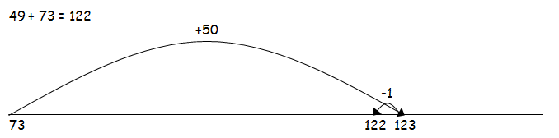
Adding in columns
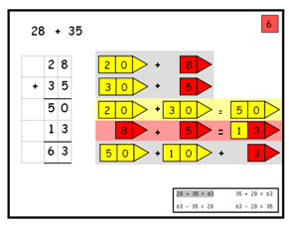
Step 1 – adding most significant number first with place value cards

Fractions
Encourage your child to find fractions on a number line 0 to 1

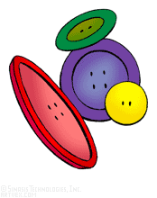
0 ¼ ½ 1

Use 12 buttons, paper clips or dried pasta
Ask the children to:
- Show you half
- Find one quarter of the group
- Find two qarters
Repeat with other amounts
Dice game
Roll two dice. Make two-digit numbers, e.g. if you roll a 6 and 4, this could be 64 or 46. If you haven’t got two dice, roll one dice twice. Ask your child to do one or more of the activities below.
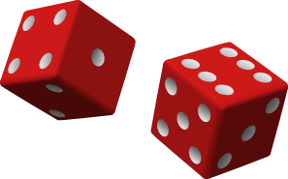
- Count on or back from each number in tens.
- Add 19 to each number in their head. (A quick way is to add 20 then take away 1.)
- Subtract 9 from each number. (A quick way is to take away 10 then add back one.)
- Double each number.
Bingo
One person has the 2x table and the other has the 5x table. Write six numbers in that table on your piece of paper, e.g.
4 8 10 16 18 20
Roll one or two dice. If you choose to roll two dice, add the numbers, e.g. roll two dice, get 3 and 4, add these to make 7.
Multiply that number by 2 or by 5 (that is, by your table number, e.g. 7 x 2 or 7 x 5).
If the answer is on your paper, cross it out.

The first to cross out all six of their numbers wins.

Pasta race


You need two dice and a pile of dried pasta.
Have two sets of cards.
Set 1: 1, 2, 3, 4, 5 an10
Set 2: 0, 1, 2, 3, 4, 5, 6, 7, 8, 9, 10
Take turns to take a card from each set of cards.
Multiply the two numbers and call out the answer.
If you are right, you win a piece of pasta.
The first to get 10 pieces of pasta wins.


Secret sums

Ask your child to say a number, e.g. 43.
Secretly do something to it (e.g. add 30). Say the answer, e.g. 73.
The child then says another number to you, e.g. 61.
Do the same to that number and say the answer.
The child has to guess what you are doing to the number each time!
Then they can have a turn at secretly adding or subtracting something to each number that you say to them.

Make 20

For this game you need to write out numbers 0 to 20 on a piece of paper. Make them big enough to put counters or coins on.
Take turns. Roll a dice. Put a coin on the number that goes with the dice number to make 20, e.g. throw a ‘4’ and put a coin on 16.
If someone else's counter is there already, replace it with yours!
The first person to have counters on 6 different numbers wins.

Step 2

Adding the least significant digit with place value cards

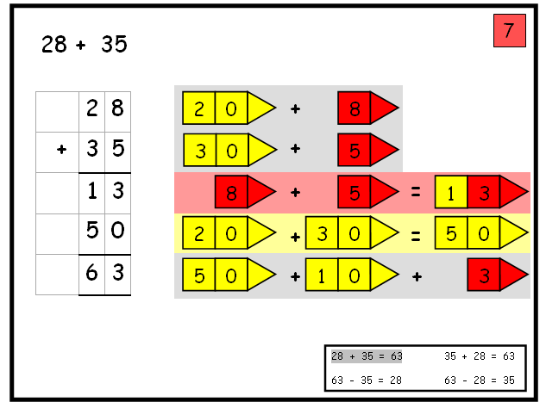

Adding the least significant digit first, without place value cards

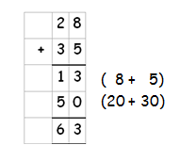

Subtraction

Pupils are encouraged to partition numbers (split) and subtract the most significant digit first. Initially, they need to use numbers that do not need to be exchanged.

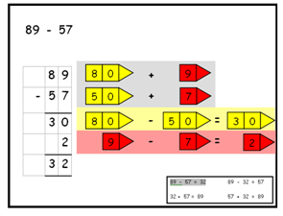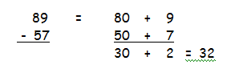
They then begin to exchange

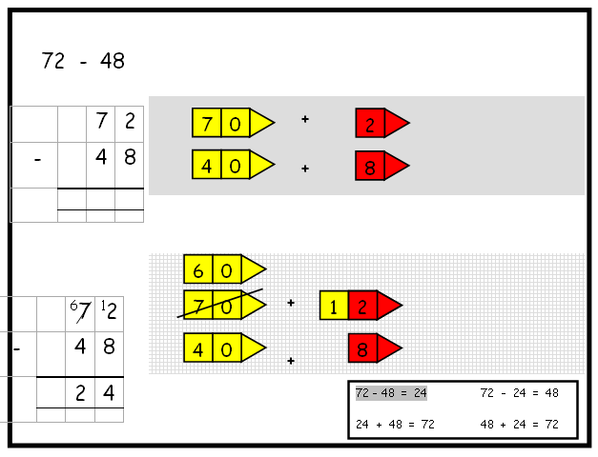
‘

Pupils can then use these known facts to help them solve problems where there is an ‘unknown’ value.

30 ÷ 5 =

30 ÷ = 6

6 x 5 = 30
5 x 6 = 30
30 ÷ 5 = 6
30 ÷ 6 = 5

Division

There needs to be an emphasis on grouping rather than sharing

Pupils use repeated subtraction on a number line e.g.

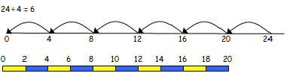

Pupils will also be introduced to remainders

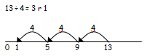

To be able to link known facts together:

Buy one, get three free!

For example, if they know that,

7 x 4 = 28 then they should be able to see that 4 x 7 = 28 (multiplication can be done in any order)

These numbers can then be used to create the following divisions:

28 ÷ 7 = 4 and 28 ÷ 4 = 7

Stress to your child that when you divide a number gets smaller, therefore you MUST start with the largest number.
Here are a variety of number based games that you can encourage your children to play – why not play as a family?

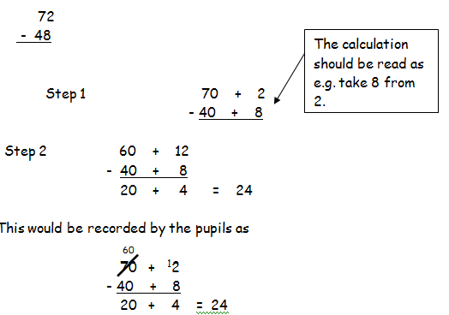

Where the numbers involved are close together or near to multiples of 10, 100 etc counting on using a number line should be used.

For example:
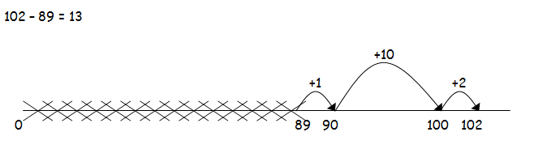

Multiplication

Tables – pupils learn these in families

1, 2 and 4 family
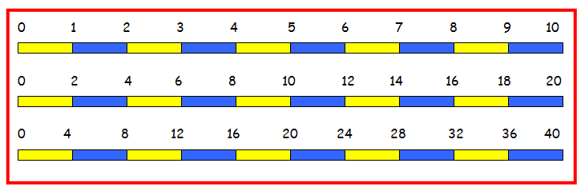

1, 5 and 10 family

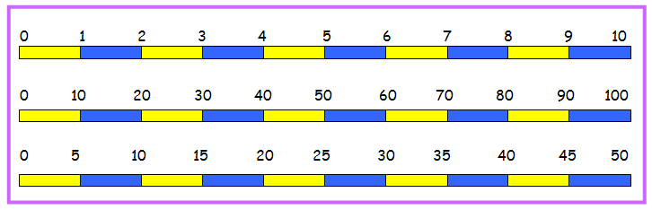

1 and 3 family

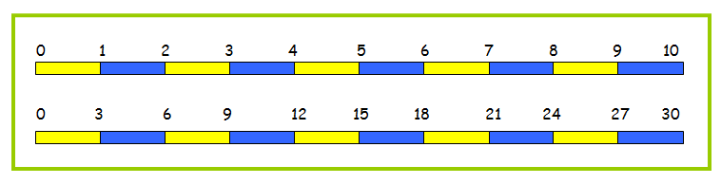
Written methods:

Multiplication as repeated addition

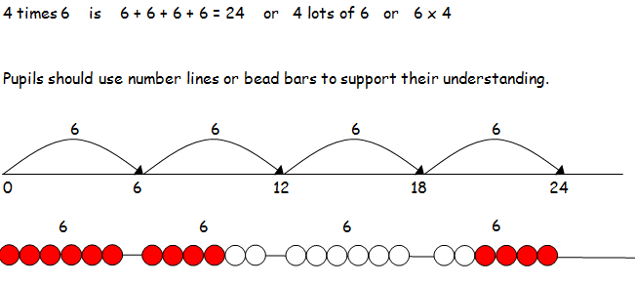

Pupils should draw multiplications as arrays (this will help with work further on in their learning)
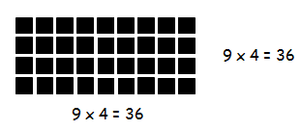

Multiplication by partitioning (splitting)


