http://www.bbc.co.uk/schools/parents/resources/
www.mathszone.co.uk
http://www.woodlands-junior.kent.sch.uk/maths/
http://www.coolmath4kids.com/
http://www.comberps.newtownards.ni.sch.uk/maths_games_for_ks1.htm
http://www.year2maths.co.uk/numberfacts/num1/make10/make10.htm
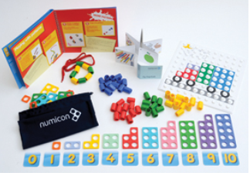
http://www.ngfl-cymru.org.uk
www.numicon com
www.mangahigh.com
www.parentsintouch.co.uk

Numicon at Home Kit £30.89

Maths is all around us and we’re using it
every day!
Many of you will already be doing these
mathematical activities and practising your
child’s numerical skills without even thinking
about it!
The most important thing is to make learning
maths FUN!

Booklet 2
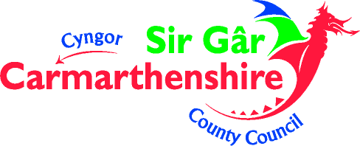

Whatever you do, make sure your children ENJOY their Mathematics!
If they struggle to understand, make mistakes or get bored; keep calm, make it easier, change the subject, tell them a joke, play football, go to the park but please don’t get cross or impatient – you could put them off maths for life!

Addition
Pupils will begin to use ‘empty number lines’ themselves starting with the larger number and counting on.
First counting on in tens and ones.
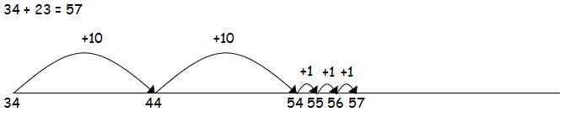
When helping pupils to become more efficient by adding the digits in one jump (by using the known fact 4 + 3 = 7)
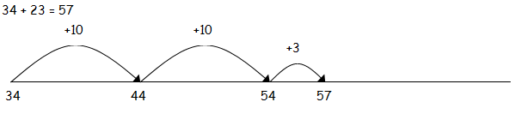
Followed by adding the tens in one jump and the units in one jump.
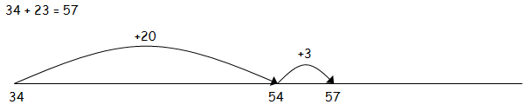
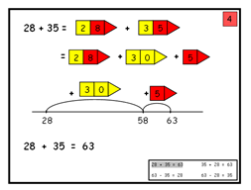
- Bridging through ten can help pupils become more efficient.
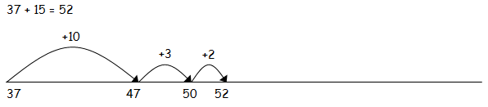

Speedy pairs to 10
Make a set of 12 cards showing the numbers 0 to 10, but with two 5s.
If you wish, you could use playing cards.
- Shuffle the cards and give them to your child.
- Time how long it takes to find all the pairs to 10.
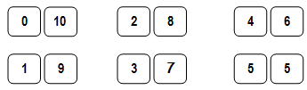

Repeat later in the week. See if your child can beat
his/her time.

Guess my shape
- Think of a 2-D shape (triangle, circle, rectangle, square, pentagon or hexagon). Ask your child to ask questions to try and guess what it is.
- You can only answer Yes or No. For example, your child could ask: Does it have 3 sides? Or: Are its sides straight?
- See if he/she can guess your shape using fewer than five questions.
- Now ask them to choose a shape so you can ask the questions
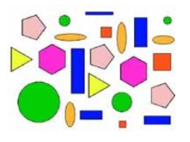
Here are a variety of number based games that you can encourage your children to play – why not play as a family?

Number facts
You need a 1–6 dice.
- Take turns. Roll the dice. See how quickly you can say the number to add to the number on the dice to make 10, e.g.

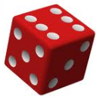
6 and ____
- If you are right, you score a point.
- The first to get 10 points wins.
You can extend this activity by making the two numbers add up to 20, or 50.

Shopping maths
After you have been shopping, choose 6 different items each costing less than £1. Make a price label for each one,
e.g. 39p, 78p. Shuffle the labels. Then ask your child to do
one or more of these.
- Place the labels in order, starting with the lowest.
- Say which price is an odd number and which is an even number.
- Add 9p to each price in their head.
- Take 20p from each price in their head.
- Say which coins to use to pay exactly for each item.
- Choose any two of the items, and find their total cost.
- Work out the change from £1 for each item.
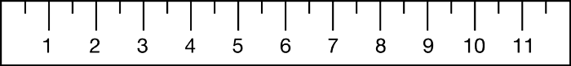
Straight lines
Choose 4 toys and lay them on the table in order of length. Use a ruler to measure each toy to the nearest cm.

Subtraction
Pupils will begin to use extended hundred squares and empty number lines to support calculations.
Counting back
First counting back in tens in ones
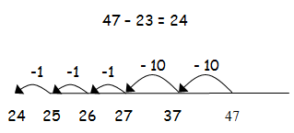
Then helping pupils to become more efficient by subtracting the units in one jump (by using the known fact 7 – 3 = 4).

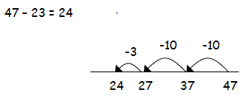
Subtracting the tens in one jump and the units in one jump.
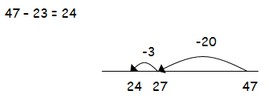

Counting on
If the numbers involved in the calculation are close together or near to multiples of 10, 100 etc, it can be more efficient to count on. Count up from 47 to 82 in jumps of 10 and jumps of 1.The number line should still show 0 so pupils can cross out the section from 0 to the smallest number. They then associate this method with ‘taking away’

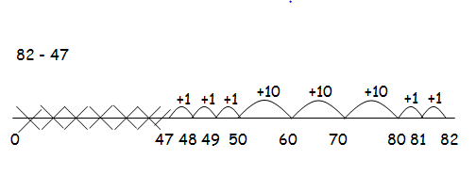
Multiplication

Repeated addition can be shown easily on a number line

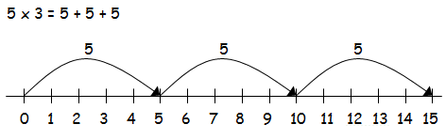

Pupils should know that 3 x 5 has the same answer as 5 x 3. This can also be shown on the number line.

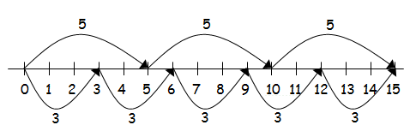

Pupils should be able to model a multiplication calculation using an array. This knowledge will support with the development of the grid method.

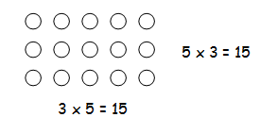

Division

Pupils will develop their understanding of division and use jottings to support calculation

Sharing Equally

6 oranges shared between 2 people, how many do they each get?
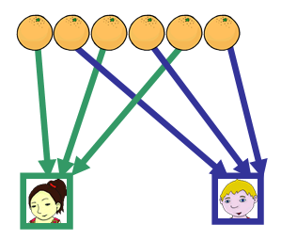
Grouping or repeated subtraction

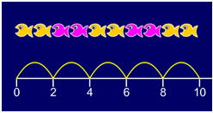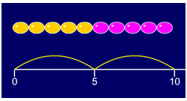

Repeated subtraction using a number line or bead bar

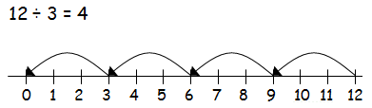

Using symbols to stand for unknown numbers to complete equations using inverse operations


