http://www.bbc.co.uk/schools/parents/resources/
www.mathszone.co.uk
http://www.woodlands-junior.kent.sch.uk/maths/
http://www.coolmath4kids.com/
http://www.comberps.newtownards.ni.sch.uk/maths_games_for_ks1.htm
http://www.year2maths.co.uk/numberfacts/num1/make10/make10.htm
http://www.ngfl-cymru.org.uk
www.mangahigh.com
www.parentsintouch.co.uk

Maths is all around us and we’re using it
everyday!
Many of you will already be doing these
mathematical activities and practising your
child’s numerical skills without even thinking
about it!
The most important thing is to make learning
maths FUN!

Booklet 5


Whatever you do, make sure your children ENJOY their Mathematics!
If they struggle to understand, make mistakes or get bored; keep calm, make it easier, change the subject, tell them a joke, play football, go to the park but please don’t get cross or impatient – you could put them off maths for life!

Addition
At this level pupils will move on from the use of number lines and will begin to ‘‘carry’’ below the line, using the correct mathematical vocabulary.
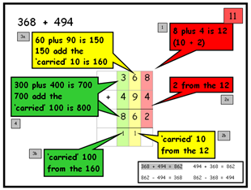

Pupils should extend the ‘carrying’ method to numbers with at least four digits.

587 3587
+ 475 + 675
1062 4262
¹ ¹ ¹ ¹ ¹

Games
Decimal number plates
Choose 2 digits from a car registration plate.
Make the smallest and largest numbers you can, each with 1 decimal place, e.g. 5.6 and 6.5.
Now find the difference between the two decimal numbers,
Whoever makes the biggest difference scores 10 points.
The person with the most points wins. 
e.g. 6.5 – 5.6 = 0.9.
Play the game again, but this time score 10 points for the smallest difference, or 10 points for the biggest total.
(If you add the numbers)

Battleship
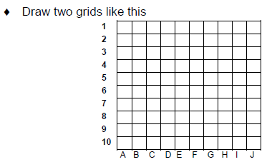
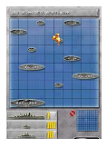

- Choose ships of various lengths (use between 2 and 4 squares)
- Hide your grid from your partner
- Take it in turns to guess the co-ordinates of your opponents ships.
- Respond with ‘hit’ or ‘miss’
- Try to get as close to possible to 555
- The winner is the person to sink all their opponents ships.

How much?
While shopping, point out an item costing less than £1.
Ask your child to work out in their head the cost of 3 items.
Ask them to guess first. See how close they come.

If you see any items labelled, for example, ‘2 for £3.50’, ask them to work out the cost of 1 item for you, and to explain how they got the answer.

Times Tables

Say together the six times table forwards, then backwards. Ask your child questions, such as:
Nine sixes? How many sixes in 42?
Six times four? Forty-eight divided by six?
Three multiplied by six? Six times what equals sixty?
Repeat with the seven, eight and nine times tables.

Make a times tables grid like this:
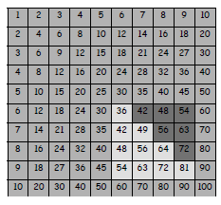
*Shade in all the tables facts that your child knows, probably the 1s, 2s, 3s, 4s, 5s and 10s.
*Some facts appear twice, e.g. 7 x 3 and 3 x 7, so cross out one of each.
*Are you surprised how few facts are left?
*There might only be 10 facts to learn. So take one fact a day and make up a silly rhyme together to help your child to learn it, e.g. nine sevens are sixty-three, let's have lots of chips for tea!
Pupils should extend their methods to decimal numbers.
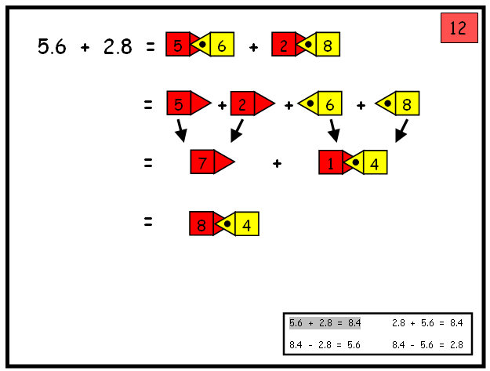

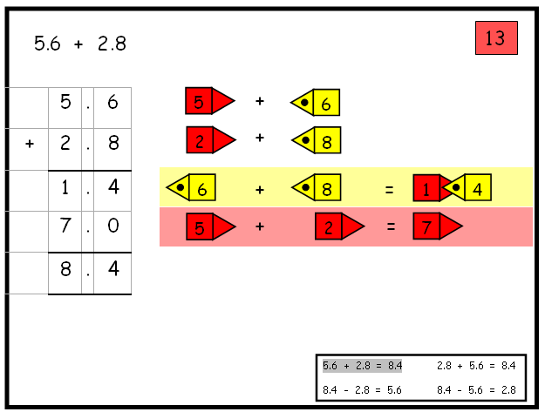

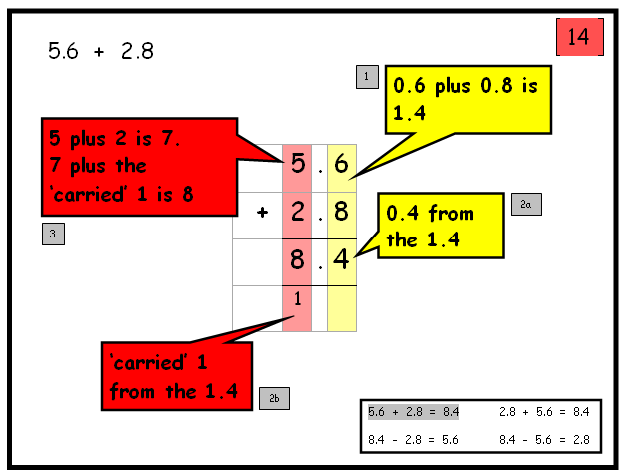

Subtraction

Pupils are encouraged to partition numbers (Split).

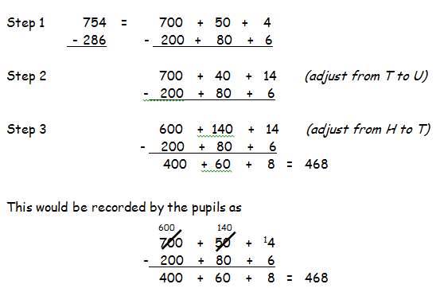

Decomposition (break down into smaller parts)

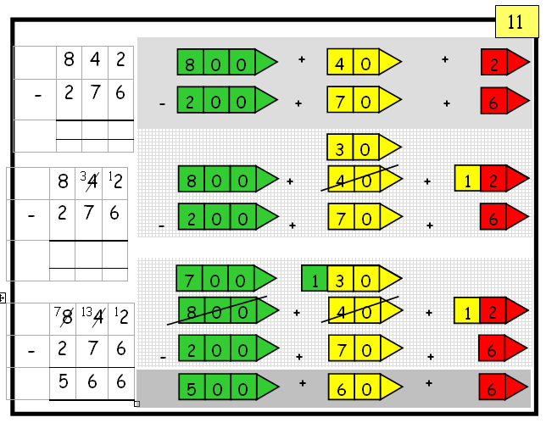

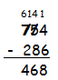

Pupils will continue to use written methods to solve short division
TU ÷ U.

Pupils can start to subtract larger multiples of the divisor, e.g. 30x

Short division HTU ÷ U

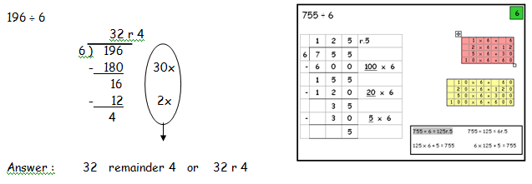

Any remainders should be shown as integers, i.e. 14 remainder 2 or 14 r 2.

Children need to be able to decide what to do after division and round up or down accordingly. They should make sensible decisions about rounding up or down after division. For example 240 ÷ 52 is 4 remainder 32, but whether the answer should be rounded up to 5 or rounded down to 4 depends on the context.

Division

Dividing by 10 or 100

Knowing that the effect of dividing by 10 is moving the digits one place to the right.

Knowing that the effect of dividing by 100 is moving the digits two places to the right.

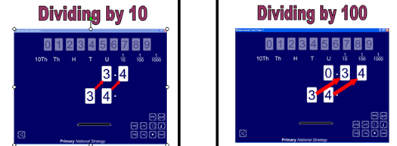

Pupils should:
- be able to subtract numbers with different numbers of digits;
- begin to find the difference between two decimal fractions with up to three digits and the same number of decimal places;
- know that decimal points should line up under each other.

Where the numbers are involved in the calculation are close together or near to multiples of 10, 100 etc counting on using a number line should be used.

1209 – 388 = 821

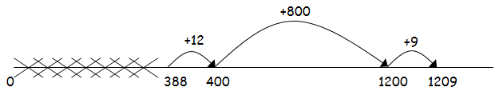

Tables – pupils learn these in families

1, 2 ,4 & 8 family
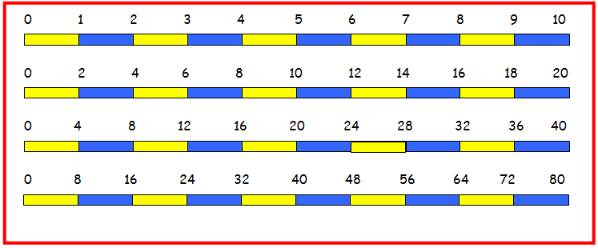

1, 5 and 10 family
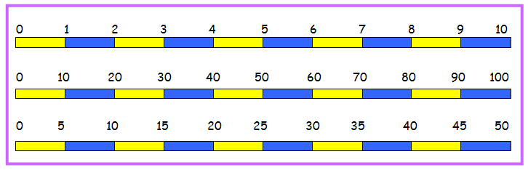

1,3,6 & 9 family
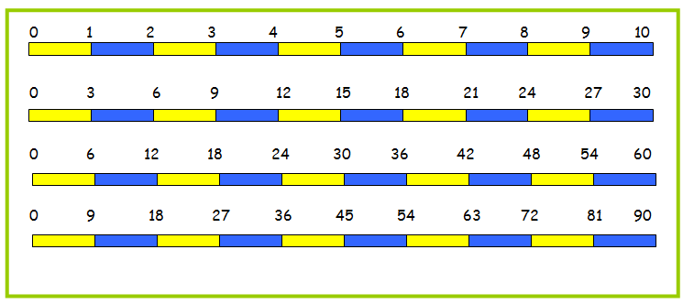

1 & 7 family
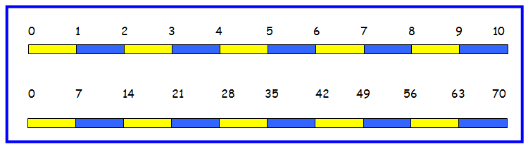

Multiplying by 10 or 100
Knowing that the effect of multiplying by 10 is a shift in the digits one place to the left.
Knowing that the effect of multiplying by 100 is a shift in the digits two places to the left.
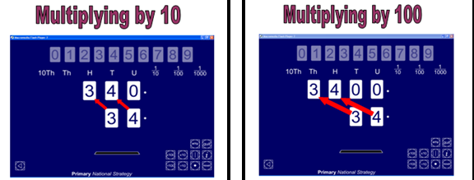
Written method:

Grid Method:- Children will approximate first
346 x 9 is approximately 350 x 10 = 3500
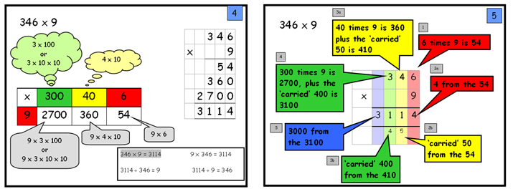

Long Multiplication


