http://www.bbc.co.uk/schools/parents/resources/
www.mathszone.co.uk
http://www.woodlands-junior.kent.sch.uk/maths/
http://www.coolmath4kids.com/
http://www.comberps.newtownards.ni.sch.uk/maths_games_for_ks1.htm
http://www.year2maths.co.uk/numberfacts/num1/make10/make10.htm
www.ngfl-cymru.org.uk
www.parentsintouch.co.uk

Maths is all around us and we’re using it
everyday!

Many of you will already be doing these
mathematical activities and practising your
child’s numerical skills without even thinking
about it!
The most important thing is to make learning
maths FUN!

Booklet 4

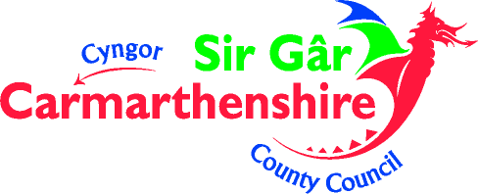

Whatever you do, make sure your children ENJOY their Mathematics!
If they struggle to understand, make mistakes or get bored; keep calm, make it easier, change the subject, tell them a joke, play football, go to the park but please don’t get cross or impatient – you could put them off maths for life!

Addition
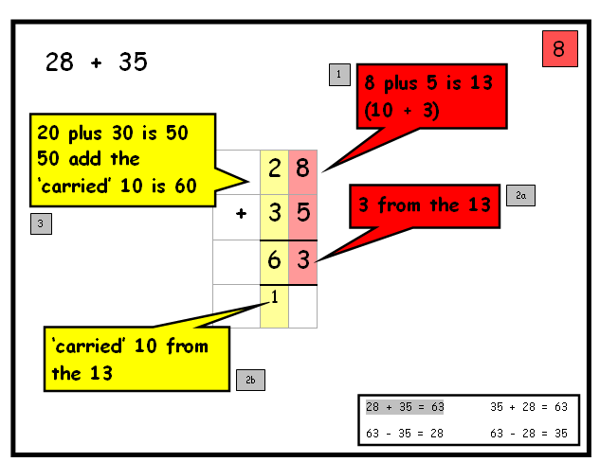
Pupils are taught to carry below the line for smaller numbers

For larger numbers (hundreds) pupils use the partition (splitting) method initially
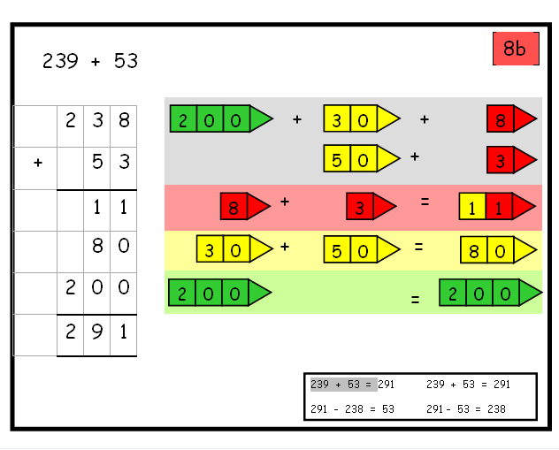

Pairs to 100
This is a game for two players.
Each draws 10 circles. Write a different two-digit number in each circle – but not a ‘tens’ number (10, 20, 30, 40…).
In turn, choose one of the other player’s numbers.
The other player must then say what to add to that number to make 100, e.g. choose 64, they need to add 36.
If the other player is right, she crosses out the chosen number.
The first to cross out 6 numbers wins.

Dicey division
You each need a piece of paper. Each of you should choose five numbers from the list below and write them on your paper.
5 6 8 9 12 15 20 30 40 50
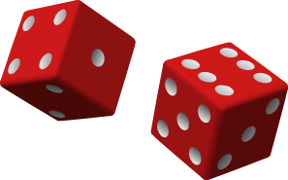
Take turns to roll a dice. If the number you roll divides exactly into one of your numbers then cross it out, e.g. you roll a 4, it goes into 8, cross out 8.
If you roll a 1, miss that go. If you roll a 6 have an extra go.
The first to cross out all five of their numbers wins.

Tables
Practise the 3x, 4x and 5x tables. Say them forwards and backwards.
Ask your child questions like:
What are five threes? What is 15 divided by 5?
What is seven times three? How many threes in 21?
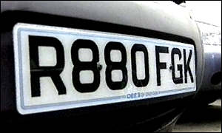
Out and about
Choose a three-digit car number, e.g. 569.
Make a subtraction from this, e.g. 56 – 9.
Work it out in your head. Say the answer.
If you are right, score a point.
The first to get 10 points wins.
Here are a variety of number based games that you can encourage your children to play – why not play as a family?
Number game 1
You need about 20 counters or dried pasta.
Take turns. Roll two dice to make a two-digit number, e.g. if you roll a 4 and 1, this could be 41 or 14.
Add these two numbers in your head. If you are right, you win a counter. Tell your partner how you worked out the sum.
The first to get 10 counters wins.
Now try subtracting the smaller number from the larger one.
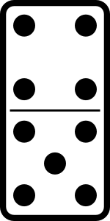
Number game 2
Put some dominoes face down
Shuffle them. Each chooses a domino.
Multiply the two numbers on your domino.
Whoever has the biggest answer keeps the two dominoes.
The winner is the person with the most dominoes when they have all been used.

Number game 3
Use three dice. If you have only one dice, roll it 3 times.
Make three-digit numbers, e.g. if you roll 2, 4 and 5
Ask your child to round the three-digit number to the nearest multiple of 10. Check whether it is correct, e.g.
Roll again. This time round three-digit numbers to the nearest 100.

Left overs
Take turns to choose a two-digit number less than 50.
Write it down. Now count up to it in fours. What number is left over?
The number left is the number of points you score, e.g.
The first person to get 12 or more points wins.
Choose 27.
Count: 4, 8, 12, 16, 20, 24.
3 left over to get to 27. So you score 3 points.
Now try the same game counting in threes, or in fives.
Can you spot which numbers will score you points

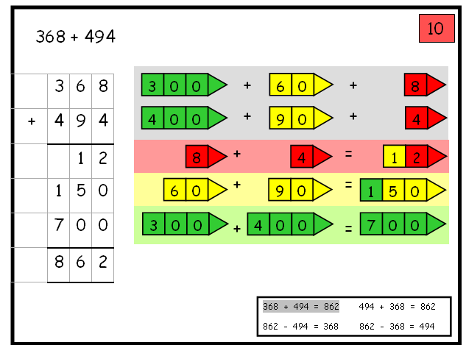

Pupils then progress to using the carry method with larger numbers

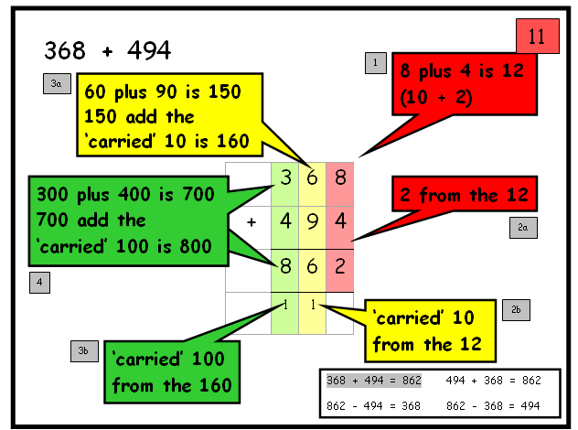

Subtraction

Pupils are encouraged to partition numbers (split) numbers
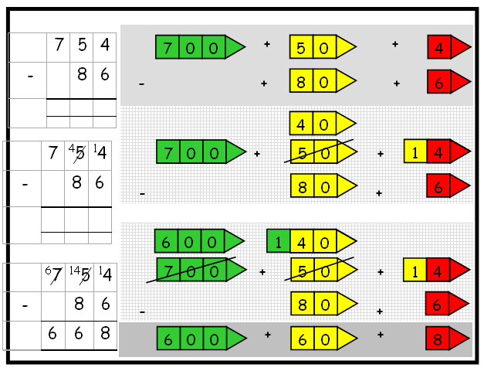

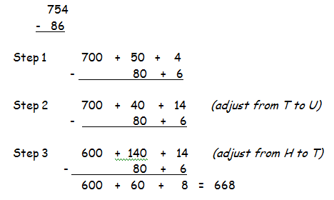
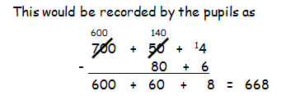

This will get recorded by the pupils like this
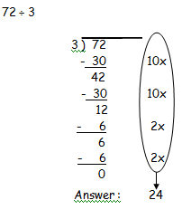

Pupils will then be introduced to remainders and will record like the example below

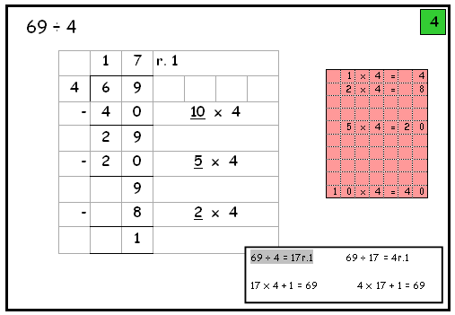

Division

Pupils develop their use of repeated subtraction to subtract multiples of the divisor

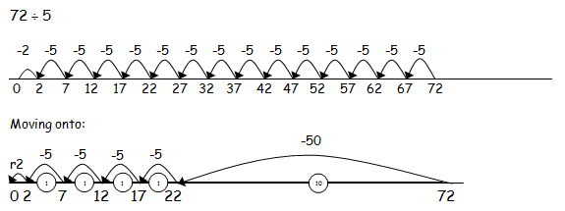

They then move onto the column method of recording
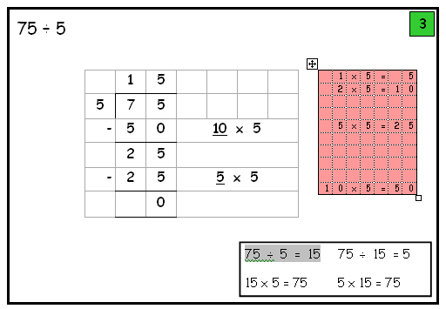

Moving on, pupils then complete this operation using columns and carrying

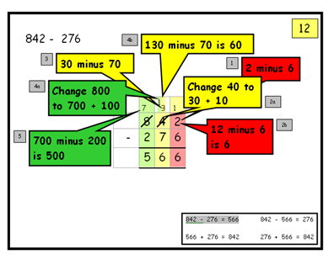

Recorded as -
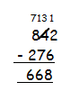

Multiplication

Tables – pupils learn these in families

1, 2, 4 and 8 family
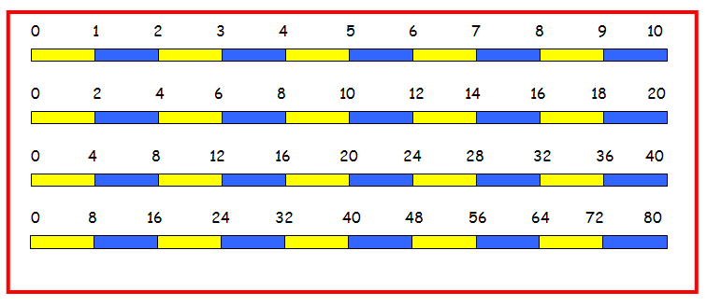

1, 5 and 10 family
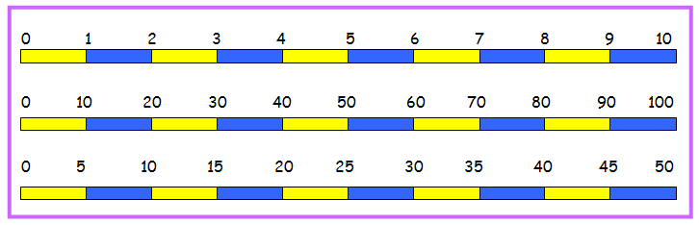

1, 3, 6 and 9 family
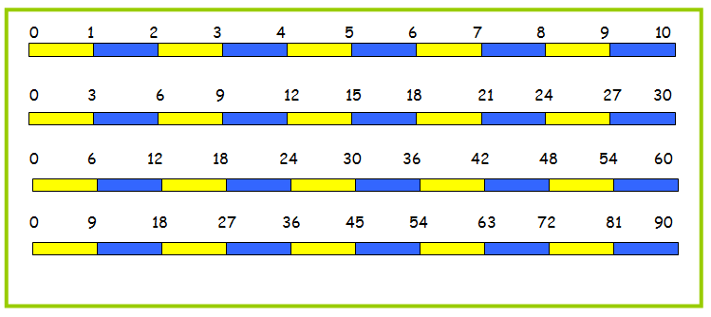
Pupils build upon what they have learnt and continue to use the array method to help solve multiplication calculations
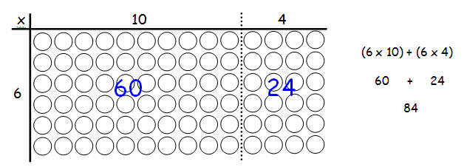

Pupils then move onto using the grid method to solve TU x U calculations
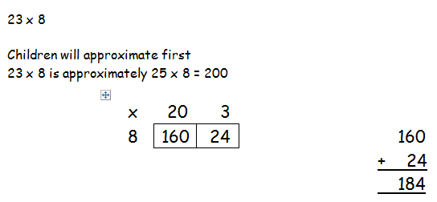

They then move onto representing the calculation in columns



