http://www.bbc.co.uk/schools/parents/resources/
www.mathszone.co.uk
http://www.woodlands-junior.kent.sch.uk/maths/
http://www.coolmath4kids.com/
http://www.comberps.newtownards.ni.sch.uk/maths_games_for_ks1.htm
http://www.year2maths.co.uk/numberfacts/num1/make10/make10.htm
www.ngfl-cymru.org.uk
www.mangahigh.com
www.parentsintouch.co.uk

Maths is all around us and we’re using it
everyday!
Many of you will already be doing these
mathematical activities and practising your
child’s numerical skills without even thinking
about it!
The most important thing is to make learning
maths FUN!

Booklet 6
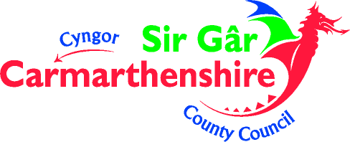

Whatever you do, make sure your children ENJOY their Mathematics!
If they struggle to understand, make mistakes or get bored; keep calm, make it easier, change the subject, tell them a joke, play football, go to the park but please don’t get cross or impatient – you could put them off maths for life!

Addition
Pupils extend the carrying method to include any number of digits

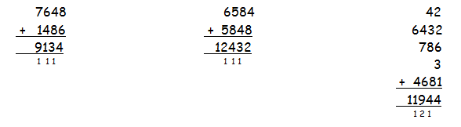
Subtraction
Pupils extend the carrying method to include any number of digits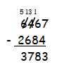
Where the numbers are close together or are close to multiples of 10, 100 or 1000, pupils should use a number line
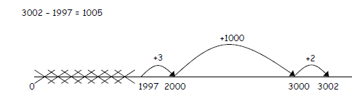

Remainders
Draw a 6 x 6 grid like this

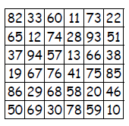

Choose the 7, 8 or 9 times table.
♦ Take turns.
♦ Roll a dice.
♦ Choose a number on the board, e.g. 59. Divide it by the tables number, e.g. 7. If the remainder for 59 ÷ 7 is the same as the dice number, you can cover the board number with a counter or coin.
♦ The first to get three of their counters in a straight line wins!

Doubles and trebles
Roll two dice.
Multiply the two numbers to get your score.
Roll one of the dice again. If it is an even number, double your score. If it is an odd number, treble your score.
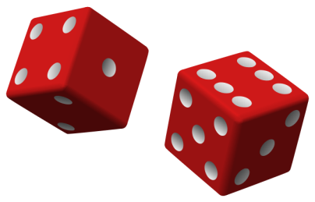
Keep a running total of your score.
The first to get over 301 wins.

Here are a variety of number based games that you can encourage your children to play – why not play as a family?

Four in a line

Draw a 6 x 7 grid, like this:

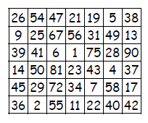
Fill it with numbers under 100.

- Take turns
- Roll 3 dice
- Use all three numbers to make a number on the grid.
- You can add, subtract, multiply or divide the numbers,
- e.g. if you roll 3, 4 and 5, you could make 3 x 4 – 5 = 7,
54 ÷ 3 = 18, (4 + 5) x 3 = 27, and so on.
- Cover the number you make with a coin or counter.
- The first to get four of their counters in a straight line wins.

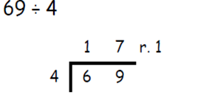
Multiplication
Pupils develop and build upon the grid method previously used
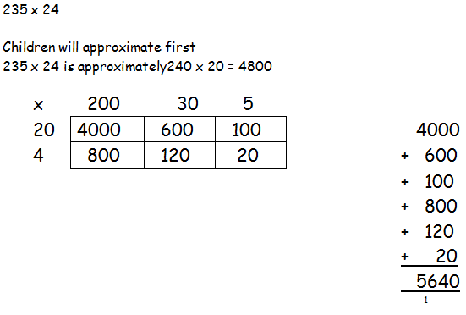
They then move onto recording it in columns
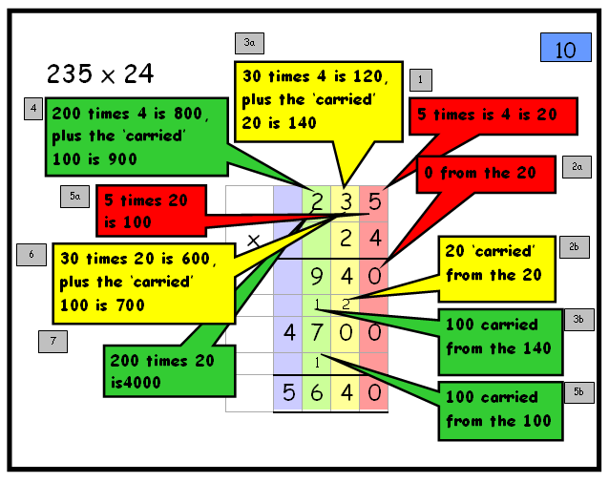

Division
Pupils solve calculations through long division
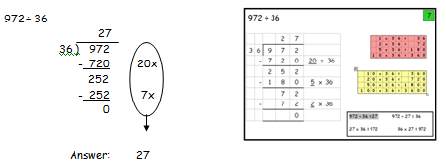

Rhymes

Make up rhymes together to help your child to remember the harder times-tables facts, e.g.
6 x 7 = 42 phew! 7 x 7 = 49 fine! 6 x 8 = 48 great!

Favourite food

Ask your child the cost of a favourite food item
Ask them to work out the cost of 7, 8 or 9 of them
How much change would there be from £50?
Repeat with their least favourite food



Card game

Using a pack of cards with the Kings, Queens, Jacks and Jokers removed.

- Take turns to roll the dice and pick a card
- Multiply the two numbers together
- Write down the answers and keep a running total
- The first to go to 301 is the winner

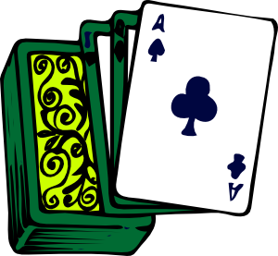

Sale of the century

When you go shopping or see a sale ask your child to work out the cost with:
- 50% off
- 25% off
- 10% off
- 5% off



Ask them to explain how they worked it out.

Animals
Take turns to think of an animal.
Use an alphabet code, A = 1, B = 2, C = 3... up to Z = 26.
Find the numbers for the first and last letters of your animal, e.g. for a TIGER, T = 20, and I = 9,
Multiply the two numbers together, e.g. 20 x 9 = 180.
The person with the biggest answer scores a point.
The winner is the first to get 5 points.



